Rising Stars Reading Planet

A
DFE
Validated Scheme
Explanation

What is Rocket Phonics?
Rocket Phonics is a fully resourced, systematic synthetic phonics programme that provides you with everything you need to teach children to read and write. It provides a combination of digital and printed resources, and a fully matched series of decodable reading books. As the resources are provided digitally within the Rocket Phonics Online subscription, it is an ideal resource for school-based and remote teaching and learning. (See the Teacher User Guide in Rocket Phonics Online for more information.)

Big Books
At the heart of the programme are the digital-only ‘Big Books’, which consist of language-rich stories to teach all the target letter-sounds in context. These books are designed for use on an IWB at the front of the class. or via the school’s remote-learning platform.
Decodable words containing the focus letter-sound appear in blue lozenges that can be clicked to hear the pronunciation
Story text for the teacher to read aloud, or play the audio version (with sound effects)
Target letter-sounds appear in yellow lozenges that can be clicked to play the pronunciation

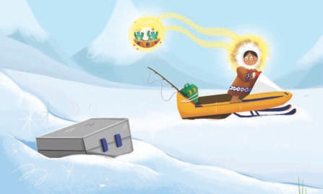The skidoo raced over a bump and the tin lunchbox flew off the back. Whoosh!
Nan didn’t realise her lunch was gone! n N
Nan

Nap

Nip and Nap didn’t want Nan to go without her lunch.
Nip
They used their amazing mind power to make Nan look around and see the tin box in the snow.

Nan jumped onto her skidoo and sped through the snow. Nip and Nap followed behind her without being seen.
tin
12 13

Story text contains words with the target letter-sound to support phonemic awareness
You can use the tools provided in the programme to zoom into
illustrations, frame items, add sticky notes, etc.
Click on the Flashcard and Games buttons to launch the resources

Flashcards

READING PLANET ROCKET PHONICS

The Flashcards are designed for reviewing previously taught letter-sounds as well as introducing new letter-sounds. They are available as print and digital versions. The digital versions can be launched from the Big Books and include audio of the letter-sounds and example words.
Flashcard 60

Common exception words are also included as flashcards, such as the examples below:
Lower-case and capital letters
p
P
Decodable word on the reverse
Picture mnemonic
Colour band level
5
Flashcard
Copyright © 2021 Hodder & Stoughton Ltd
Reading Planet: Rocket Phonics
to
Copyright © 2021 Hodder & Stoughton Ltd Flashcard 60
Reading Planet: Rocket Phonics
in

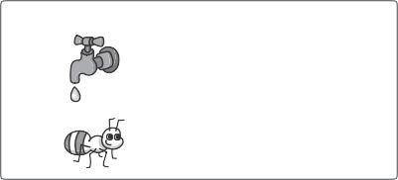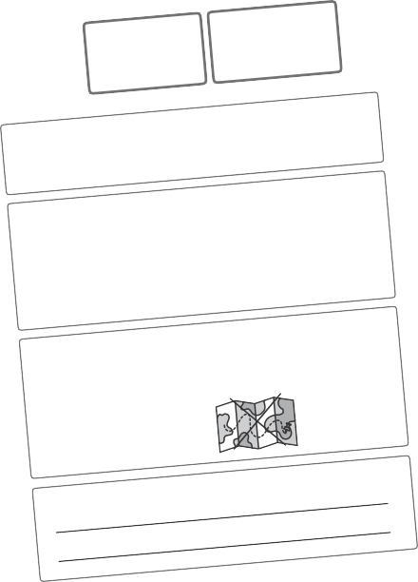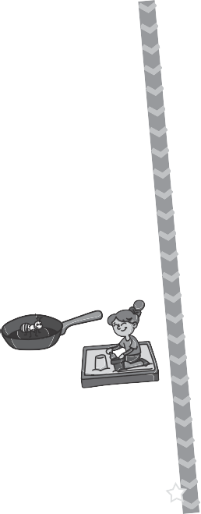Pupil Practice Booklets
31
Assessment A
1. I know these sounds. Say and tick.
c a i m
g p o d
n
s
t
r
2. I can read these words. Say and tick.
sip pen cot rug
fell dig luck map
hat
tick
bus
tap
62
© Hodder & Stoughton Limited 2021. Photocopying is prohibited.
s a t i p n
1. Revisit and review: Say and tick each sound.
t s p a n i t p
2. Blending practice: Read and tick each word.
at as in
pan ant nap
sit
tap
tip
tin
3. Segmenting practice: Look and write the words.
a p t
t n a
28
© Hodder & Stoughton Limited 2021. Photocopying is prohibited.
5. I can write a sentence:
4. I can read this sentence:
Sal got on the big red bus.
3. I can write these words. Listen and write.
The Pupil Practice Booklets enable children to practise and apply blending
and segmenting skills at letter-sound, word, sentence and text levels. These are available as printed booklets for the children to complete. A read-only version is available digitally for teacher reference and for display when explaining the activities to the children.

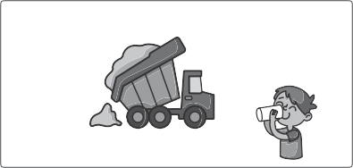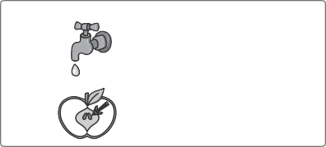
Left-hand pages focus on blending skills for reading
1. Revisit and review: Say and tick each sound.
i t I a p
P
S
T
/p /
3. Blending practice: Decode and match the words to the pictures.

sip
tip
tap

4. Apply: Tick the sentence that matches the picture.
It is a pit. It is a pip.
10
© Hodder & Stoughton Limited 2021. Photocopying is prohibited.
1. Revisit and review: Listen to the sounds and point to the letters.
t s a i p I P
A
/p /
3. Segmenting practice: Look and write the words.
p t a
i p p
© Hodder & Stoughton Limited 2021. Photocopying is prohibited.
11
Right-hand pages focus on segmenting skills for spelling and writing
4. Apply: Let’s write a sentence.
2. Grapheme write: Copy the letters and say the sound as you write.
p p p P P P
2. Grapheme search: Find and circle all the p letters.

Pip has a pink pen.
How many did you spot?
P
p
There are also review and common exception words pages, and two mini-assessments the end of each booklet.

Frieze and Sounds Mats

READING PLANET ROCKET PHONICS

The Frieze and Sounds Mats are available to download and print off from the Online Subscription. They can be used as a visual reference to support letter-sound recognition, letter formation and spelling.

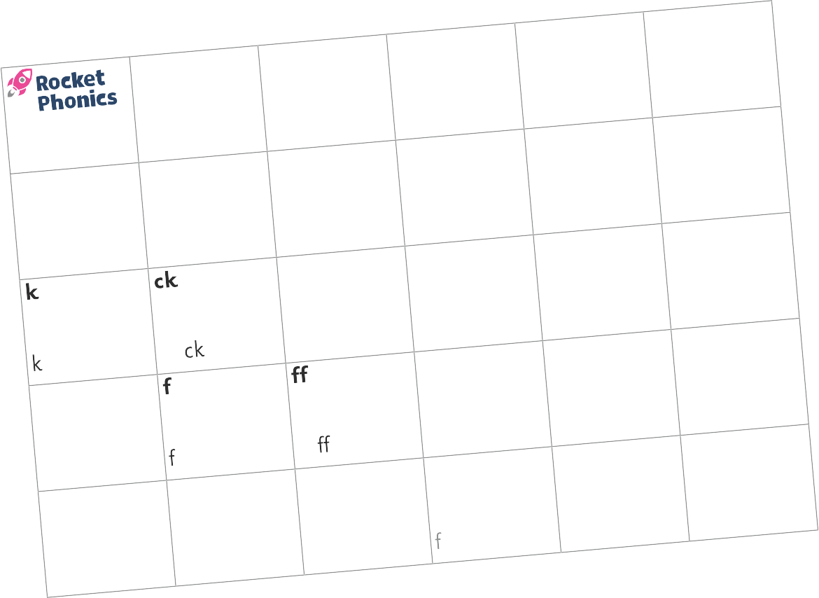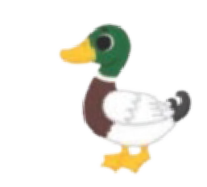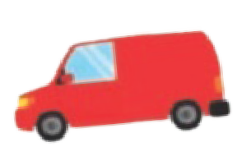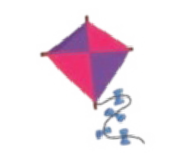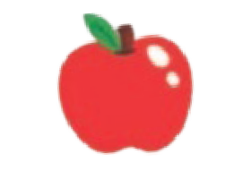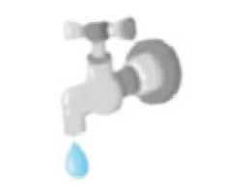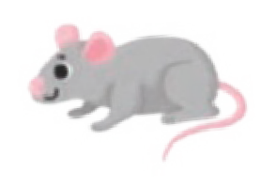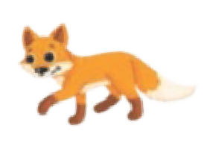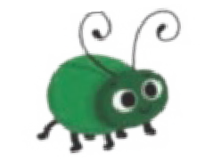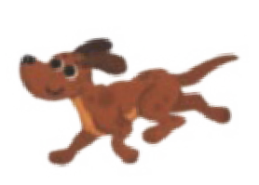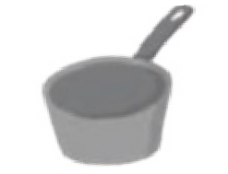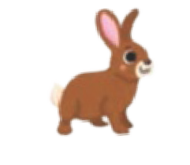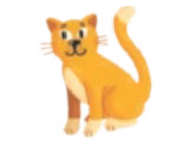/p/ p
The Frieze is provided in sections that can be displayed on the wall

Reading Planet: Rocket Phonics Copyright © 2021 Hodder & Stoughton Ltd 5

/n/ n

The Sounds Mats can be printed out and laminated for reference on classroom tables

Reading Planet: Rocket Phonics Copyright © 2021 Hodder & Stoughton Ltd 6

7

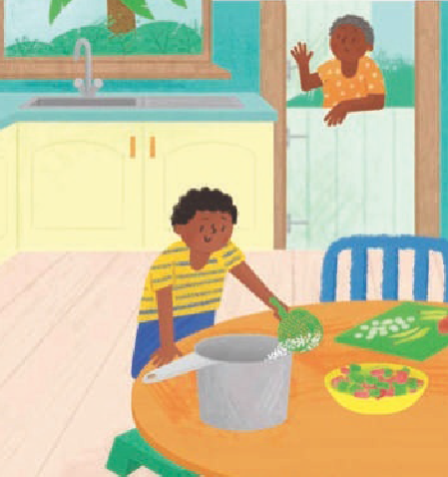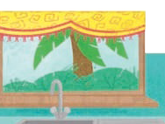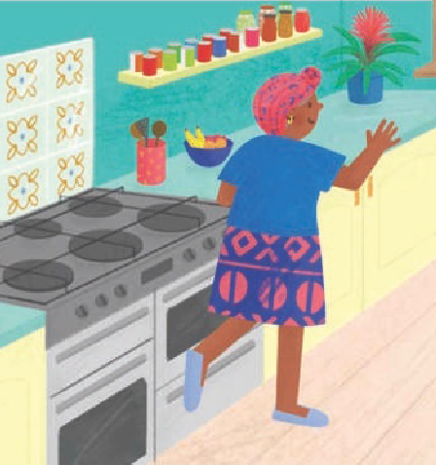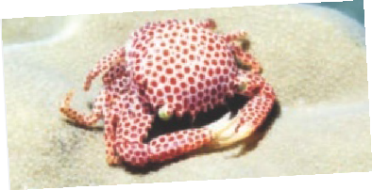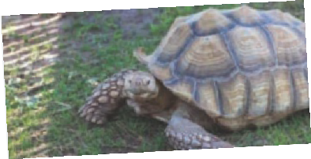Target Practice reading books
4
5
Sample pages from: The Pan
(Target Practice, Pink A)
Sample pages from: Wings and Things (Target Practice, Red B)
Cream or pastel backgrounds behind text to reduce visual disturbance
Pat tips it into the pan.
There are also some non-fiction books
Clear, child-friendly font
Most of the Target Practice books are stories
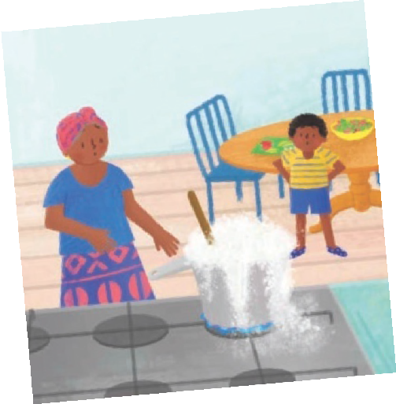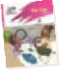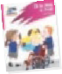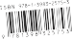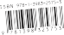The Target Practice reading books provide focused practice of small groups of target letter-sounds. The books are fully decodable and fully aligned witha the programme, and can be used for whole-class, group guided, one-to-one and independent reading. (See the weekly lesson plans for when these books become decodable.)
Book band colour and phonics phase
The books are available as print editions as well as ebooks within the Online Subscription that can
be assigned to children for home use. The ebook versions include audio and comprehension quizzes with results that feed through to the reporting area.

Target letter-sounds listed on back covers

Some examples of pages from the Target Practice reading books:

Rocket Phonics fundamentals
There are some fundamental concepts that cannot be compromised on if you want to be successful with phonics. These are essentials, and you’ll find that they are a common thread across other high quality systematic synthetic phonics (SSP) programmes, research studies and expert guidance. They are central to the pedagogy behind the Rocket Phonics programme.
Fundamental concepts
1. Phonics is overseen by a dedicated
phonics leader.
7. The Teaching & Learning Cycle (revisit and review, teach, practise, apply) is followed.
2. Phonics is taught for a minimum of 30 minutes daily.
8. Children are supported to keep up, so they do not need to catch up.
3. All staff are supported with regular phonics professional development training.
9. Phonics is taught at letter-sound, word, sentence and text levels.
4 A clear pathway is followed through the alphabetic code.
10. Core phonics provision is distinguished from phonics enrichment activities.
5 Children are not asked to read texts by themselves that they can’t yet read.
11. Teachers have clarity about what, why and how they are teaching.
6. The Systematic Synthetic Phonics Teaching 12. Teachers focus on details, such as accurate Principles (see page 14) are taught explicitly. modelling and pencil hold.

Phonics glossary

READING PLANET ROCKET PHONICS

You won’t find unnecessary amounts of terminology in Rocket Phonics, but it’s good for your professional development to know these phonics-related terms:

adjacent consonants | Two (or three) consonant letters representing two (or three) sounds, e.g. tw, str, bl. (Also known as a consonant cluster or blend.)
blending | The process of using phonics for reading. Children identify and blend the phonemes in order to hear and say (discern) a whole word. (Also known as decoding or synthesising.)
code | The English Alphabetic Code is the correlation between the sounds of speech and the individual letters or groups of letters used to represent those sounds in print. A ‘piece of code’ refers to a letter-sound correspondence or grapheme-phoneme correspondence.
common exception word (CEW) | A high frequency word with an unusual letter-sound correspondence, e.g. one, their, because. These words are taught by decoding the familiar part and pointing out the unusual part.
consonant digraph | Two consonant letters which represent one sound.
CVC, CCVC, CCVCC | These represent the consonant and vowel sounds in word structures. For example, a CVC word = h-e-n, b-oa-t or ch-i-p.
decoding | See blending
digraph | Two letters which together represent one sound, e.g. ai, ea, mb. There are different types of digraph – vowel, consonant and split.
encoding | See segmenting
grapheme | A letter or group of letters representing one sound (phoneme).
phoneme | The smallest unit of sound in a word. Represented in print using slash marks, e.g. /a/.
quadgraph | Four letters which together represent one sound, e.g. eigh, ough.
schwa | An unstressed syllable. It is common for people to pronounce various graphemes as an /uh/ sound in natural speech.
segmenting | The process of using phonics for spelling and writing. Children listen to the whole word and break it down into constituent phonemes, choosing the corresponding grapheme to represent each phoneme. For example, ‘lunch’ can be segmented as l-u-n-ch. (Also known as encoding.)
split digraph | Two letters, which work as a pair to represent one sound, but are separated within the word, e.g. a–e in cake; o–e in note.
synthesising | See blending
trigraph | Three letters which together represent one sound, e.g. igh, eer.
vowel digraph | A digraph in which at least one of the letters is a vowel, e.g. ee, oi, or.

