Core Elements of Phonics
The entire scope of phonics is incredibly complex, but that doesn’t mean we can’t take a closer look at some of the key elements which make up the basics. Let’s take a look at some of the different knowledge and skills involved in learning with phonics:
Phonemes and graphemes
Graphemes and phonemes are in essence what make up the majority of human communication. In short, these two different aspects of phonics represent the base of all language.
Graphemes are letters and groups of letters that represent the sounds of English speech. They come in a variety of different patterns:
- 1 letter graphemes – such as the “c” in the word “cat”. This represents the hard /k/ sound.
- 2 letter graphemes (digraphs) – such as “ea” in the word “leaf”. Here the /ee/ sound is represented.
- 3 letter graphemes (trigraphs) – such as “igh” in the word “might”. In this case the /igh/ phoneme is represented by a combination of letters.
- 4 letter graphemes – such as “ough” in “through”. This represents the long /oo/ sound.
These are all examples we experience on a daily basis. We don’t think about them in these terms, as they’re engrained in our daily speech and writing. As you can see, some letter combinations may surprise you with the sounds they represent.
It’s for this reason that learning to break down grapheme combinations can sometimes be easier for children. While “ough” might look complex to a new reader, learning it translates to a long /oo/ sound helps keep things simple.
If graphemes are the letters, phonemes are the sounds those symbols make. Every sound you hear within a word is an individual phoneme. As an example, let’s take a look at the word “dog”. This can be broken up into three phonemes:

- D – A regular /d/ sound
- O – Which in this instance creates an /o/ sound
- G – Ending the word with a standard /g/
In total, there are as many as 44 phonemes in the English language. In time, after being introduced systematically to the sounds and the graphemes that are code for the sounds, a child will come to recognise all of these naturally, without even having to think about them.
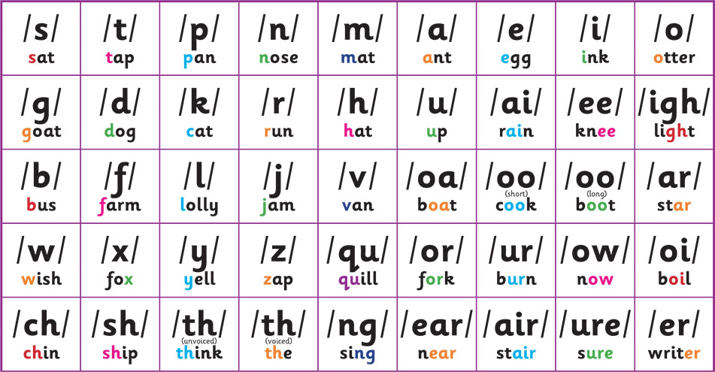
Within these, there are 24 consonant sounds and 20 vowels. Each of these creates a unique sound to make up our spoken communication. You’ll use every one of them throughout the course of any conversation.
Ironically, it’s the fact it’s so second nature to us which makes it hard to teach to children. We don’t think about words and language as phonemes, which means as adults we need to be informed about how we approach words and language when teaching phonics.

Phonemic awareness
Phonemic awareness is an awareness of speech sounds at the level of the phoneme (the smallest sounds of speech). Children are trained in phonemic awareness to support their reading and spelling ability. The stronger a child’s phonemic awareness, the better their chances are of being able to develop a solid grasp of reading and writing.
Teachers train children in phonemic awareness to support the phonic skills of decoding (sounding out and blending) which is why they need to be specifically taught. Children with a poor awareness will often struggle the most to pick up reading skills. This will often be conveyed through annoyance or frustration. Typical struggles might be along the lines of:

- I can’t think of any words that rhyme with “dog”
- I don’t know how to work out how many syllables there are in a word
- I find it hard to recognise the constituent sounds in words
We’ll cover later what both parents and teachers can do to help with issues children are having, but there are methods you can encourage kids to take on themselves to improve. These include:
- Playing word games which make learning engaging and fun
- Being patient with themselves. It’s hard for kids, but it helps to explain to them that it can take a lot of repetition and practice to embed the knowledge and skills needed to become a fluent reader
- Practising hearing sounds in words
- Practice writing – maybe even breaking down words into individual syllables

Blending and segmenting

Blending and segmenting are the processes through which children combine phonemes and graphemes together to read and spell words. Blending refers to the ability to read, while segmenting refers to spelling and writing.
Blending involves combining phonemes together, by first identifying the letter-sound correspondences all through the word, saying the sounds individually and then discerning the spoken word as one continuous sound. Segmenting by contrast sees a child identifying the constituent phonemes all through the spoken word then allotting the correct graphemes.
The quicker a child can learn to blend, the faster they’ll be able to understand exactly what they’re reading. That in mind, it’s also important they’re actually taking in what the author has written. Comprehension is just as important as the ability to read the words on the page.
Segmenting is the process of a child trying to break down words they’re unfamiliar with and spelling them using the correct graphemes. This will often have mixed results. The more familiar a child is with the pattern of phonics, the more likely they are to get things right. The adult needs to help the child with the correct spelling as there are so many spelling alternatives.

