0
North Duffield community primary school
N

Progression

Progression across key stages
Primary | Computing systems and networks | Programming | Data and information | Creating media
themes
Taxonomy strands | Computer systems | Programming | Data and information | Creating media
 |  | Algorithms
 | Computer networks | Design and development |  | Design and development
 | Effective use of tools
 | Impact of technology
 | Safety and security

All learning objectives have been mapped to the National Centre for Computing Education’s taxonomy of ten strands, which ensures that units build on each other from one key stage to the next.

Progression across year groups

Within the Teach Computing Curriculum, every year group learns through units within the same four themes, which combine the ten strands of the National Centre for Computing Education’s taxonomy (see table, right).

This approach allows us to use the spiral curriculum approach (see the ‘Spiral curriculum’ section for more information) to progress skills and concepts from one year group to the next.

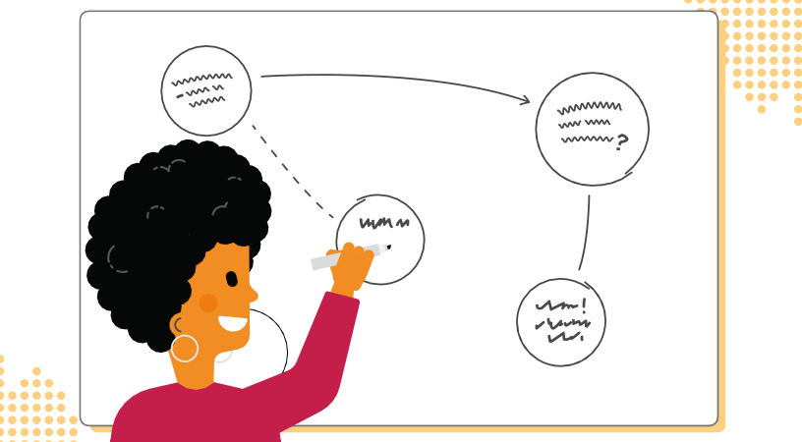
Progression within a unit — learning graphs
Learning graphs are provided as part of each unit and demonstrate progression through concepts and skills. In order to learn some of those concepts and skills, pupils need prior knowledge of others, so the learning graphs show which concepts and skills need to be taught first and which could be taught
at a different time.

The learning graphs often show more statements than there are learning objectives. All of the skills and concepts learnt are included in the learning graphs. Some of these skills and concepts are milestones, which form learning objectives, while others are smaller steps towards these milestones, which form success criteria. Please note that the wording of the statements may be different in the learning graphs than in the lessons, as the learning graphs are designed for teachers, whereas the learning objectives and success criteria are age-appropriate so that they can be understood by pupils.

In each year group, there are two ‘Programming’ units of work, but only one ‘Programming’ learning graph. The second ‘Programming’ unit builds on the

content that was taught in the first ‘Programming’ unit so closely that there is no specific divide where one ends and the other begins.

Example
Y3 – Branching databases – learning graph
To investigate questions with yes/no answers
To retrieve information from different levels of the branching database
To create questions with yes/no answers
To identify the object attributes needed to collect relevant data
To explain that data can be used to answer questions
To compare the information shown in a pictogram with a branching database
To relate two levels of a branching database
using AND
To select an attribute to separate objects into two similarly sized groups
To decide what data needs to be collected to answer a specific question

